Daniel Fryer
Assignment 1.2
Link to GitHub account: https://github.com/XcitedMonkie/csd-340.git
Local directory screenshot:
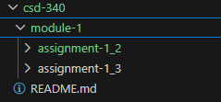
Step 2 Git Setup:
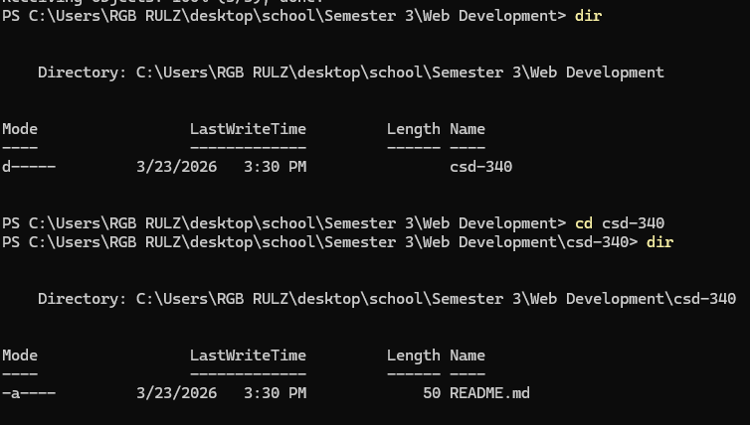
Step 3: Update the Readme file
